BEYOND THE WIRE
PART 4

Signal Analysis &
Modulation Identification
From spectrum observation to digital signal intelligence
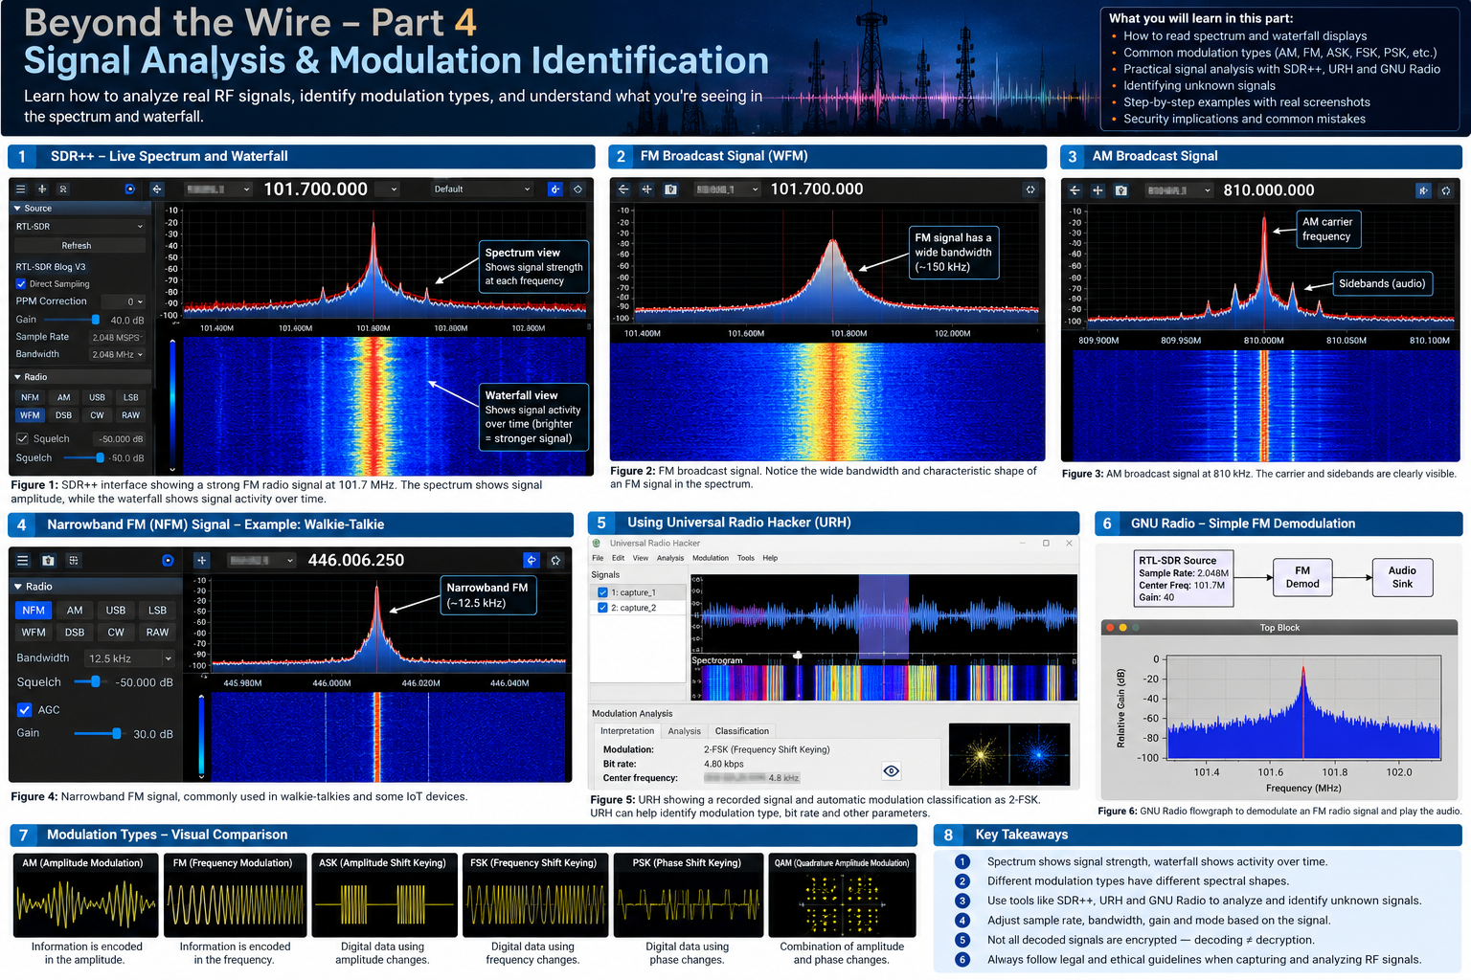
Illustrative overview generated for this article. Interface panels and signal traces are conceptual, not live measurements.

Article information
Field | Details
Series | Beyond the Wire
Part | 4
Category | RF Security | Wireless Communication | Software Defined Radio
Level | Beginner to Intermediate
Tools | SDR++, Universal Radio Hacker (URH), GNU Radio, Python
Hardware requirement | None for the software simulations in this article

Important note about screenshots and experiments
This edition is designed for readers who do not currently own an SDR. It uses conceptual illustrations, software references and reproducible offline simulations. The included overview image is illustrative and must not be represented as a genuine capture from physical SDR hardware. Check licences and permissions before reusing third-party screenshots.

Introduction – The language of wireless communication
Wireless communication is not magic. Devices exchange information using electromagnetic waves and carefully designed signalling techniques. Mobile phones communicate with cellular infrastructure; wireless sensors send measurements to gateways; aircraft use dedicated communication and surveillance systems; and satellites exchange information with ground stations.
Although these systems serve different purposes, they share a common foundation: radio-frequency (RF) signals. For a cybersecurity researcher, understanding those signals is an important first step toward understanding wireless security.
RF signal analysis begins with observable physical characteristics—frequency, amplitude, phase, bandwidth, timing and signal behaviour. These observations guide further investigation, but do not independently identify a device, protocol or vulnerability.

1. The RF signal – understanding the basics
A simplified sinusoidal carrier can be represented as:
x(t) = A cos(2πft + φ)
A is amplitude, f is frequency, t is time and φ is phase. These properties form the foundation of many modulation techniques.

Frequency, amplitude and phase
- Frequency is the number of cycles completed per second, measured in Hertz (Hz). Common units include kHz, MHz and GHz.
- Amplitude describes signal magnitude. SDR applications may display dBFS, while calibrated equipment may report dBm; these are not interchangeable without calibration and a known reference.
- Phase describes a waveform's position within its cycle. It is especially important in BPSK, QPSK and other phase-based modulation schemes.

2. Time domain and frequency domain
A time-domain view shows how a signal changes over time. A frequency-domain view shows how signal energy is distributed across frequencies. An oscilloscope commonly presents time-domain information, while a spectrum analyser presents frequency-domain information.

The Fast Fourier Transform (FFT)
The Fast Fourier Transform is an efficient algorithm for calculating the Discrete Fourier Transform. It helps reveal frequency components in sampled data and is central to SDR spectrum displays.
Frequency-bin spacing = Sample rate / FFT size
For a sample rate of 2,000,000 samples per second and an FFT size of 2048, the bin spacing is approximately 976.56 Hz. FFT size, windowing and averaging influence the display.
- Dominant frequency components
- Harmonics and spurious components
- Broadband noise and narrowband energy
- Frequency drift and interference patterns
- Changes in signal bandwidth
An FFT peak is evidence of energy at a frequency; it is not proof of a particular transmitter, protocol or malicious activity.

3. Spectrum versus waterfall
Display | What it represents | Useful questions
Spectrum | Signal level against frequency at a moment or averaged interval | Where is energy concentrated? What is the approximate bandwidth?
Waterfall | Successive spectrum measurements displayed over time | Is activity continuous, intermittent, moving or periodic?

Waterfall colours represent relative intensity according to the application's palette and scale. A bright trace often indicates stronger energy relative to the displayed range, but colour values are not universal measurements.
Common patterns include persistent narrow traces, repeated bursts, broad regions of energy and frequency-changing traces. Interpret them as observations rather than definitive protocol classifications.

4. I/Q data – the foundation of SDR
Software Defined Radio systems commonly represent sampled baseband signals using complex I/Q samples. I is the in-phase component and Q is the quadrature component.
z(t) = I(t) + jQ(t)
This representation preserves amplitude and phase information and supports digital filtering, frequency translation, demodulation and offline analysis.
- Confirm the sample rate and centre-frequency metadata.
- Identify whether samples are float32, int16 or another format.
- Check whether I and Q values are interleaved.
- Confirm scaling, endianness and channel arrangement.
- Do not infer a file's sample format from its extension alone.

5. Sample rate, bandwidth and Nyquist

Sample rate and bandwidth
Sample rate is the number of samples collected per second. A rate of 2 MS/s means two million samples per second. Bandwidth is the frequency range occupied by a signal or passed by a processing system. Occupied bandwidth depends on modulation, symbol rate, pulse shaping and filtering.

Nyquist and aliasing
For a band-limited real-valued signal, the sampling rate must exceed twice the highest frequency component to avoid aliasing under ideal conditions. Complex baseband sampling is commonly described differently: the complex sample rate determines the approximate total observation bandwidth around the tuned centre frequency.
Aliasing causes frequency components to be represented incorrectly. It can create misleading spectrum observations, so sample-rate selection and filtering matter.

6. Modulation – how information is encoded
Modulation changes a carrier's properties to represent information. Analog modulation includes AM and FM; digital modulation includes ASK, FSK, PSK and QAM.
Technique | Property changed | High-level description
AM | Amplitude | Carrier amplitude follows the message signal.
FM | Instantaneous frequency | Carrier frequency varies with the message.
PM | Phase | Carrier phase varies with the message.
ASK / OOK | Amplitude states | Digital symbols use amplitude levels; OOK is a simple on/off form.
FSK | Frequency states | Digital symbols use discrete frequencies.
BPSK | Two phase states | Two phase states represent binary symbols.
QPSK | Four phase states | Four symbols can represent two bits per symbol.
QAM | Amplitude and phase | Symbols use combinations of amplitude and phase states.

16-QAM, 64-QAM and 256-QAM use increasingly large symbol alphabets. Higher-order schemes can carry more bits per symbol, but generally require better signal quality and more accurate synchronisation.

7. Constellation diagrams
A constellation diagram plots digital symbols on an I/Q plane. The horizontal axis represents the in-phase component and the vertical axis represents the quadrature component. Each ideal point corresponds to a possible transmitted symbol.
BPSK has two ideal points, QPSK has four, and 16-QAM has sixteen. In a real receiver, noise, phase error, frequency offset and distortion can spread points around their ideal positions. Interpretation requires a correctly configured receiver and suitable synchronisation.

8. Symbol rate, bit rate and bandwidth
Symbol rate is the number of symbols transmitted per second and is measured in baud. Bit rate is the number of bits transmitted per second. For a modulation scheme carrying k bits per symbol, the uncoded bit rate is:
Bit rate = Symbol rate × Bits per symbol
For example, QPSK carries two bits per symbol. At 100,000 baud, its uncoded bit rate is 200,000 bits per second, before coding, framing and protocol overhead. Bandwidth is related to symbol rate and pulse shaping, but is not identical to bit rate.

9. SNR and noise
Signal-to-Noise Ratio (SNR) compares desired signal power with noise power. In decibels:
SNR (dB) = 10 log₁₀(Signal power / Noise power)
A higher SNR generally makes detection and demodulation easier. Noise and interference can originate from thermal effects, receiver electronics, nearby transmitters, electrical equipment, poor antenna placement and nonlinear behaviour.
Availability and resilience testing should be conducted only in controlled, authorised environments. Do not jam or interfere with operational services.

10. Software-based analysis without SDR hardware
Not owning an SDR does not prevent learning the fundamentals. GNU Radio can generate synthetic signals; Python can create waveforms and calculate FFTs; and URH can be explored with suitable sample recordings.

GNU Radio
GNU Radio Companion provides a graphical flowgraph environment. A synthetic signal can be created with a Signal Source, passed through a Throttle block to control simulation speed, and viewed using a QT GUI Frequency Sink. A Noise Source and Add block can be introduced to study noise.
Conceptual chain: Signal Source → optional processing blocks → QT GUI Time Sink / Frequency Sink. This is a simulation, not an RF transmission.

Universal Radio Hacker
URH can inspect supported recorded signals. Import a sample, inspect its waveform and spectrogram, examine timing and test analysis settings. Confirm the sample's origin, format and licence, and label it as a supplied sample rather than a personal capture.

Python
Python libraries such as NumPy, SciPy and Matplotlib support waveform generation, FFT calculations, filtering, spectrograms and constellation plots.

11. Practical offline experiment – generate and analyse a signal
Requirements: Python 3, NumPy and Matplotlib. No SDR hardware is required.
import numpy as np
import matplotlib.pyplot as plt
sample_rate = 100_000
duration = 0.05
frequency = 5_000
t = np.arange(int(sample_rate * duration)) / sample_rate
signal = np.cos(2 * np.pi * frequency * t)
# Time-domain view
plt.figure()
plt.plot(t[:500], signal[:500])
plt.title("Synthetic Baseband Signal")
plt.xlabel("Time (seconds)")
plt.ylabel("Amplitude")
plt.grid()
plt.show()
# Frequency-domain view
spectrum = np.fft.fftshift(np.fft.fft(signal))
frequencies = np.fft.fftshift(
np.fft.fftfreq(len(signal), 1 / sample_rate)
)
magnitude = 20 * np.log10(
np.abs(spectrum) / len(signal) + 1e-12
)
plt.figure()
plt.plot(frequencies, magnitude)
plt.title("FFT Spectrum")
plt.xlabel("Frequency (Hz)")
plt.ylabel("Magnitude (dB)")
plt.grid()
plt.show()
Expected observations: a periodic time-domain waveform, a dominant spectral component near 5 kHz, and a symmetric spectrum because the generated signal is real-valued. Frequency resolution is determined by sample rate divided by the number of samples.

12. Practical experiment – add noise
noise = np.random.normal(0, 0.3, len(signal))
noisy_signal = signal + noise
plt.figure()
plt.plot(t[:500], noisy_signal[:500])
plt.title("Synthetic Signal with Added Noise")
plt.xlabel("Time (seconds)")
plt.ylabel("Amplitude")
plt.grid()
plt.show()
Compare the clean and noisy signals. Change the noise standard deviation and observe how the waveform changes. This introduces SNR, filtering and detection concepts without receiving or transmitting radio signals.

13. Digital signal processing concepts
Operation | Purpose
Filtering | Attenuates unwanted frequency components.
Frequency translation | Moves a signal to another frequency region for processing.
Decimation | Reduces sample rate, normally after appropriate filtering.
Interpolation | Increases sample rate by estimating additional samples.
Demodulation | Recovers information represented by the modulated carrier.
Synchronisation | Aligns timing, carrier frequency and phase for reliable symbol recovery.

14. Modulation identification – a disciplined workflow
- Observe the signal's frequency location and approximate bandwidth.
- Inspect time-domain and spectrogram characteristics.
- Determine whether activity is continuous or burst-based.
- Examine amplitude, frequency and phase behaviour where suitable data is available.
- Estimate symbol timing only when the recording and sampling parameters support it.
- Compare observations against candidate modulation characteristics.
- Validate the hypothesis using an appropriate demodulator or analysis method.
- Document uncertainty and alternative explanations.
Different protocols can use the same modulation. Identifying FSK, for example, does not identify the exact device, manufacturer, protocol or security properties.

15. RF security implications for penetration testers
Assessment area | Questions for an authorised assessment
Confidentiality | Does the test system expose sensitive information without suitable protection?
Authentication | Does it rely on weak or predictable authentication?
Replay resistance | Does a controlled test system accept previously captured messages?
Integrity | Can the implementation detect unauthorised message modification?
Availability | How does it behave under controlled, authorised interference or degraded conditions?
Information leakage | Do timing, metadata or operational patterns reveal sensitive information?

A spectrum display cannot independently establish these vulnerabilities. Findings require protocol-level investigation, controlled validation and evidence of security impact.

16. Building a repeatable RF investigation report
Report field | What to record
Objective | What is being investigated?
Authorisation | Scope, permission and test boundaries.
Hardware and software | Receiver, antenna, software names and versions; state when simulated.
Configuration | Centre frequency, sample rate, gain, bandwidth and relevant settings.
Evidence | Screenshots, recordings, plots and source of sample data.
Analysis | Observed facts, interpretation and validation steps.
Limitations | What could not be measured or confirmed.
Conclusion | Only conclusions supported by the evidence.

17. Common mistakes
Mistake | Potential consequence
Excessive gain | Clipping and distortion.
Incorrect sample rate | Aliasing or missing signal information.
Confusing sample rate and symbol rate | Incorrect technical conclusions.
Misreading waterfall colours | Incorrect interpretation of activity or strength.
Ignoring noise | False signal identification.
Assuming every peak is a transmitter | False positives.
Assuming modulation identifies a protocol | Incorrect attribution.
Presenting a simulation as a live capture | Misleading evidence.

18. Conclusion – from observation to understanding
RF signal analysis provides a foundation for understanding wireless communication. Spectrum displays reveal frequency characteristics; waterfalls show activity over time; I/Q sampling provides a mathematical representation for signal processing; and modulation and constellation analysis help explain how information is encoded.
SDR++, URH, GNU Radio and Python make these concepts accessible even without dedicated SDR hardware. For cybersecurity researchers, these skills provide a starting point for investigating wireless systems and assessing their implementations.
Understand the signal. Investigate the protocol. Evaluate the security.

What's next – Part 5
Beyond the Wire – Part 5: RFID and NFC Security. The next article will cover RFID fundamentals, LF/HF/UHF technologies, NFC architecture, tags and readers, access-control implementations, authentication, cryptographic protection and authorised assessment methodology.

References and further learning
- SDR++ documentation: https://www.sdrpp.org/
- GNU Radio tutorials: https://wiki.gnuradio.org/index.php?title=Tutorials
- GNU Radio hardware considerations: https://wiki.gnuradio.org/index.php/Guided_Tutorial_Hardware_Considerations
- Universal Radio Hacker: https://github.com/jopohl/urh
- Inspectrum: https://github.com/miek/inspectrum
- RTL-SDR resources: https://www.rtl-sdr.com/
- Ettus Research tutorials: https://files.ettus.com/tutorials/

Image and attribution notes
The cover infographic was generated as an illustrative visual for this document. Its interface depictions and signal traces are conceptual and must not be described as actual measurements or screenshots from the author's SDR equipment. For third-party images inserted into a public website, verify the source licence and attribution requirements before republication. Prefer original diagrams and screenshots of your own simulations.

Disclaimer
This article is intended for educational purposes and authorised wireless security research. Follow applicable spectrum regulations and privacy laws. Do not intercept private communications, interfere with licensed services, or transmit RF signals without the required authorisation.

