BEYOND THE WIRE — PART 2
RF Fundamentals for Security Researchers
Frequency, wavelength, bandwidth, modulation, antennas, sampling and signal propagation—explained from a penetration tester’s perspective
Series: Beyond the Wire | Part 2
Audience: Beginners, cybersecurity learners, RF hobbyists and penetration testers

Introduction: Learn to Read the Radio Environment
In Part 1, we introduced radio frequency (RF), the wireless attack surface and Software-Defined Radio (SDR). This chapter goes deeper: what does a spectrum peak represent? Why does changing frequency affect what appears on screen? Why can an antenna improve one capture and make another worse? And why might a visible signal still fail to decode?
These questions matter in security testing because a weak capture, incorrect receiver setting or misunderstood waveform can lead to false conclusions. A disciplined researcher distinguishes physical-layer observations from protocol behavior and validated security findings.
This chapter uses plain-language explanations, simple equations and a safe lab workflow. The objective is to understand radio signals without transmitting into live services or interfering with other users.

1. Frequency, Period and Wavelength

1.1 Frequency and period
Frequency is the number of cycles per second, measured in hertz (Hz). A 1 MHz signal has one million cycles per second. The period is the time taken for one complete cycle. Frequency and period are reciprocals:
T = 1 / f
For example, a 1,000 Hz signal has a period of 1 millisecond; a 1 MHz signal has a period of 1 microsecond. This relationship connects a waveform viewed over time with the frequency-domain view shown by a spectrum analyzer.

1.2 Wavelength
Wavelength is the distance a wave travels during one complete cycle. For electromagnetic waves in free space, a useful approximation is:
λ ≈ c / f
Here, λ is wavelength in metres, c is the speed of light (approximately 300,000,000 metres per second), and f is frequency in hertz. If frequency is in megahertz, a handy approximation is wavelength in metres ≈ 300 ÷ frequency in MHz.
Frequency | Approx. wavelength | Calculation
100 MHz | 3 m | 300 ÷ 100
300 MHz | 1 m | 300 ÷ 300
1 GHz | 30 cm | 300 ÷ 1,000
2.4 GHz | 12.5 cm | 300 ÷ 2,400
These are free-space estimates. Real environments, materials and antenna design affect behavior. Wavelength helps explain antenna dimensions and propagation, but it does not tell you whether a protocol is secure.

1.3 Frequency is not data rate
A higher carrier frequency does not automatically mean faster data, a stronger signal or better security. Data rate depends on bandwidth, modulation, coding, signal quality, protocol overhead and implementation.

2. Amplitude, Phase, Power and Decibels
Amplitude describes a signal’s magnitude. Frequency describes how quickly it repeats. Phase describes where a waveform is within its cycle relative to a reference. Radio systems can encode information by changing one or more of these properties.

2.1 Understanding dB and dBm
Radio power is often expressed in dBm, a logarithmic unit referenced to one milliwatt. For power ratios, a change of about +3 dB is roughly twice the power, while −3 dB is roughly half. A +10 dB change is ten times the power. These are power relationships, not simple linear changes in displayed amplitude.
Some SDR displays show dB, dBm or a device-specific relative scale. Do not assume that a displayed value is calibrated absolute power unless the hardware and software support that interpretation.

2.2 Gain is not transmit power
Receiver gain amplifies the signal presented to the receiver’s processing chain. More gain can make weak signals easier to see, but it also raises noise and can overload the receiver in the presence of strong signals. Excessive gain can distort observations; more is not always better. Record gain settings and keep them consistent when comparing captures.

3. Bandwidth: How Much Spectrum Does a Signal Occupy?
Bandwidth is the frequency span used or occupied by a signal or system, measured in hertz. A real transmission is rarely an infinitely thin line: modulation, symbol timing, filtering and implementation spread energy across a range.
Think of bandwidth as the width of a lane assigned to a communication. If the receiver observes too narrow a slice, it may filter out part of the signal. If it observes a much wider slice than necessary, it may include more noise and unrelated signals.

3.1 Bandwidth and data rate
Bandwidth and data rate are related but not identical. Achievable data rate depends on bandwidth, signal quality, modulation, coding and protocol overhead. A wider channel may support more data under suitable conditions, but it does not guarantee higher throughput.

3.2 Configured bandwidth versus occupied bandwidth
The bandwidth setting in an SDR may refer to a tuner or digital filter. The occupied bandwidth is a property of the received transmission. These values are not necessarily the same, and applications use terminology differently. Consult the software documentation and record the exact settings.
- Too narrow: parts of a signal may be filtered out.
- Too wide: extra noise and nearby signals may be included.
- Incorrect assumptions: a displayed peak may be only part of a wider transmission.
- Reproducibility: record sample rate, bandwidth and gain with each capture.

4. Modulation: How Information Changes a Carrier
Modulation changes a carrier signal according to information being transmitted. Demodulation attempts to recover the represented symbols or data. Identifying a modulation family can help explain a signal, but visual inspection alone rarely proves which protocol is in use.

4.1 Analogue examples
In amplitude modulation (AM), the signal’s amplitude varies with the information. In frequency modulation (FM), its instantaneous frequency varies. These examples demonstrate that information can be represented by changing different properties of a carrier.

4.2 Digital modulation
- ASK/OOK: information is represented by amplitude changes; on-off keying is a simple form.
- FSK: information is represented by shifts between frequencies.
- PSK: information is represented by changes in phase.
- QAM: information is represented using combinations of amplitude and phase states.
Real systems may also use filtering, coding, interleaving, synchronization sequences and protocol framing. A modulation guess is one step toward understanding a signal, not a security conclusion.

4.3 Demodulation is not decryption
Demodulation recovers symbols or data from the received waveform. Decryption uses a cryptographic key and algorithm to recover information from protected ciphertext. A signal can be received and demodulated successfully while its contents remain encrypted. Being able to observe a signal does not prove a confidentiality failure.

5. Antennas: The Interface Between Electronics and the Air
An antenna converts electrical signals into electromagnetic waves when transmitting, and converts received electromagnetic energy into electrical signals when receiving. Its behavior depends on frequency, design, polarization, orientation and the surrounding environment.

5.1 Length and wavelength
Many antenna designs use dimensions related to a fraction of a wavelength, such as a quarter-wave or half-wave design. These are useful concepts, not universal rules: geometry, matching networks and the installation environment also matter.

5.2 Polarization and orientation
Polarization describes the orientation of the electric field. A mismatch between transmitting and receiving antenna polarization can reduce reception. Rotating an antenna can change received level even when the receiver settings remain unchanged.

5.3 Directionality and placement
Some antennas work better in certain directions. Nearby metal, cables, walls, computers and the operator’s position can affect reception. For repeatable experiments, record antenna type, orientation, placement and approximate distance from the source. A change in received strength may be caused by the antenna or environment, not a change in the target system.

6. Sampling and I/Q Data in SDR
An SDR converts the received radio signal into digital samples for software to process. Sample rate describes how many samples are captured per second, commonly expressed as samples per second or MS/s. It affects how much signal bandwidth can be represented, subject to receiver architecture and digital processing.

6.1 I/Q samples
I and Q stand for in-phase and quadrature components. Together, they allow software to represent signal magnitude and phase. An I/Q recording can be processed repeatedly offline, which is useful for reproducible research without receiving the signal again.
I/Q files can be large and may contain sensitive communications. Capture only what is authorized, store files carefully and do not publish raw recordings without considering privacy and legal restrictions.

6.2 Sampling and aliasing
Sampling theory sets limits on what can be reconstructed from digital samples. In a simplified real-valued system, the sample rate must exceed twice the highest frequency component to avoid aliasing. SDR systems often use complex I/Q sampling and tuned frequency offsets, so the usable bandwidth depends on the receiver and software design.
Aliasing occurs when signal components are represented incorrectly because of an inadequate sampling setup. Use supported device settings and consult the receiver documentation instead of applying one simplified rule to every SDR.

6.3 Sample rate is not a quality score
A higher sample rate creates more data and uses more processing resources; it is not automatically better. Select a supported rate suitable for the signal, and note that nominal sample rate and usable bandwidth may differ.

7. Reading a Spectrum and Waterfall
A spectrum plot usually places frequency on the horizontal axis and signal level on the vertical axis. Peaks show where the receiver measures relatively concentrated energy. A waterfall adds time: each row represents a time slice, and color represents signal strength according to the display scale.
A stable narrow signal may look like a thin line; a short burst may appear only briefly; a wider transmission may occupy a broader region. These are general patterns, not definitive labels. Noise, gain, filtering, averaging and other signals affect appearance.
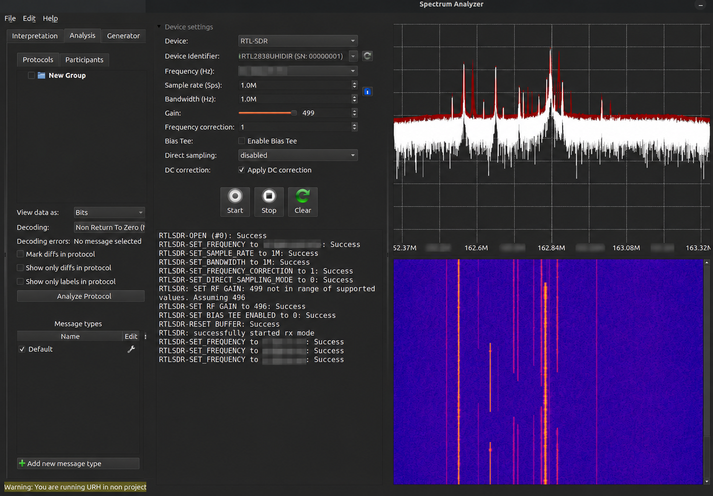
Figure 1. Example URH spectrum and waterfall view. Frequency values are blurred; visible peaks illustrate signal activity, not a confirmed vulnerability.

7.1 A careful observation workflow
- Confirm the receiver is connected and software initialization succeeds.
- Choose a signal or recording you are permitted to analyze.
- Record sample rate, bandwidth/filter, gain, antenna and environment.
- Observe the baseline before changing settings.
- Change one variable at a time and record the effect.
- Repeat observations to check whether a pattern is stable.
- Do not claim protocol identification or a vulnerability from a spectrum image alone.

7.2 Why a signal may be hard to decode
- The receiver is tuned incorrectly or the signal is outside the captured span.
- Gain is too low, or strong signals overload the receiver.
- The antenna is poorly suited to the frequency or placed unfavorably.
- Bandwidth or sample rate is unsuitable.
- The signal is intermittent, weak, noisy or overlapping with other transmissions.
- Demodulation or protocol settings are incorrect.
- The signal uses encoding, synchronization or encryption not handled by the current workflow.

8. Safe, Repeatable SDR Exercise
Use a lawful signal, a purpose-built lab setup in a compliant environment, or a sample I/Q recording. Do not transmit into public or safety-critical services.
- Open your SDR application and confirm the receiver is detected.
- Choose a permitted signal or sample recording.
- Set a supported sample rate and suitable view span.
- Observe the spectrum and waterfall for a short period.
- Adjust receiver gain slightly and note how the display changes.
- Replay a sample recording with a different visualization scale and compare.
- Write down what changed, what stayed stable and what cannot be concluded.

Example lab notes
Field | What to record
Source | Lawful signal, lab device or sample-file identifier
Receiver | Hardware model and software version
Antenna | Type, orientation and placement
Settings | Sample rate, bandwidth/filter, gain and tuning details
Observation | Peak shape, persistence, bursts or visible changes
Repeatability | Whether the result appears again
Limitations | Unknown protocol, uncertain source, noise or other caveats
The goal is not to force a decode. The goal is to make a controlled observation and describe it accurately.

9. Connecting RF Physics to Security Testing
Observation | Security question | What it does not prove
Signal visible outside a building | Is sensitive information protected and access controlled? | Visibility alone does not prove readable content or compromise.
Repeated message pattern | Are freshness and anti-replay protections used? | A repeated-looking waveform does not prove replay will work.
Strong signal peak | Can the signal be decoded and authenticated? | Strength does not indicate security or legitimacy.
Intermittent reception | Is this fading, interference or system behavior? | A drop in signal is not automatically intentional jamming.
Decoded message | Does the receiver validate origin, integrity and authorization? | Readable data does not prove message injection or control.
The distinction between observation and conclusion is essential. 'A signal was visible' is an observation. 'An unauthenticated command was accepted and changed the test device state' is a security finding only after safe, authorized, reproducible validation.

10. Safety, Law and Research Ethics
RF testing can affect people and services beyond the researcher’s equipment. Before active transmission, verify local regulations, licensing requirements, equipment limits and the conditions of the authorized test. Use shielded or otherwise compliant environments for experiments that could radiate beyond the lab.
Do not jam, spoof or interfere with operational cellular, emergency, aviation or navigation services. Passive reception and recording can also raise legal, privacy or service-specific concerns; ensure the activity and data handling are permitted. If a test could disrupt a third party, stop and redesign it around simulation or offline data.
For professional work, document scope, approval, permitted techniques, stop conditions, evidence handling and the contact who can authorize changes.

Conclusion: Observe Carefully, Conclude Conservatively
Frequency, wavelength, bandwidth, modulation, antennas and sampling explain different parts of a radio system. Each affects what an SDR can capture and how reliably the data can be interpreted. None of them alone determines whether a system is secure.
A strong RF researcher records the setup, changes one variable at a time, repeats observations and distinguishes a visible signal from a decoded protocol and a validated vulnerability. These habits make research more accurate, safer and easier to reproduce.
Good RF security starts with good measurement.

Key Takeaways
- Frequency and wavelength are related, but neither tells you whether a signal is secure.
- Bandwidth, sample rate and receiver settings influence what can be observed.
- Gain can reveal weak signals, but excessive gain can distort observations.
- Antennas and the environment strongly influence reception.
- A spectrum or waterfall display is evidence of signal activity, not proof of a vulnerability.
- Use controlled, authorized experiments and record enough details to reproduce results.

References and Further Learning
- GNU Radio — https://www.gnuradio.org/
- RTL-SDR — https://www.rtl-sdr.com/
- Universal Radio Hacker — https://github.com/jopohl/urh
- SDR++ — https://github.com/AlexandreRouma/SDRPlusPlus
- HackRF documentation — https://hackrf.readthedocs.io/
- International Telecommunication Union — https://www.itu.int/
- Check your national communications regulator for current spectrum rules before transmitting.

Coming Next: Part 3
Software-Defined Radio: Building Your First RF Security Lab. The next chapter will focus on entry-level hardware, installing and configuring SDR software, recording lawful signals, interpreting I/Q samples and creating a repeatable lab workflow.

