BEYOND THE WIRE — PART 1
Understanding RF Security and the Invisible Attack Surface
A deeper, beginner-friendly introduction to radio frequency, wireless systems, SDR and RF penetration testing
Series: Beyond the Wire | Part 1 of 18
Audience: Beginners, cybersecurity learners, penetration testers and engineers

Introduction: The Network You Cannot See
Imagine connecting to a Wi-Fi network, tapping a contactless card, unlocking a vehicle with a remote, tracking an aircraft on a map, or receiving information from a satellite. These activities look different, but they share a common property: information travels through electromagnetic energy rather than only through a physical cable.
That invisible communication path is part of the radio-frequency (RF) world. RF technology is not automatically insecure, and a radio signal being detectable does not mean its contents can be understood or changed. However, wireless communication introduces security questions that are different from those asked during a typical web or network penetration test.
A conventional web assessment may begin with domains, HTTP endpoints, authentication and application logic. An RF assessment may begin with a transmitter, receiver, antenna, signal, modulation method and protocol. It can then expand to the firmware and backend services that use the radio link.
This article builds the foundation for the Beyond the Wire series. It explains the physics and terminology in plain language, introduces the main RF attack surfaces, and shows how a researcher can begin investigating signals responsibly. Later articles will explore short-range wireless, mobile phones, aviation, navigation and—at the end of the series—satellite communications.

1. What Does 'Radio Frequency' Actually Mean?
Radio waves are a form of electromagnetic energy. They can travel through space and carry information when a system changes a property of a wave in a controlled way. Radio frequency describes the rate at which the wave oscillates. Frequency is measured in hertz (Hz): one hertz means one cycle per second.
Think of a wave as a repeating pattern. If the pattern repeats one million times each second, its frequency is one megahertz (MHz). If it repeats one billion times each second, it is one gigahertz (GHz).
- Hz — cycles per second.
- kHz — one thousand cycles per second.
- MHz — one million cycles per second.
- GHz — one billion cycles per second.

1.1 Frequency is not the same as a channel
A frequency is a point in the spectrum. A channel is a defined allocation or range used by a system. Many communications occupy a range of frequencies rather than a mathematically perfect single point. The width of that range is related to bandwidth.
A simple analogy is a road. Frequency is like a location along the road, while a channel is more like a lane or designated section. Multiple systems can operate in nearby spectrum, so equipment and protocols must be designed to coexist without causing unacceptable interference.

1.2 Examples of RF technologies
Technology | Example frequency/band | What it is used for
NFC | 13.56 MHz | Very short-range contactless interactions
Bluetooth | 2.4 GHz ISM band | Personal devices and peripherals
Wi-Fi | 2.4, 5 and 6 GHz bands where supported | Local wireless networking
GPS L1 | 1575.42 MHz | Satellite-based positioning
ADS-B | 1090 MHz; 978 MHz in some regions | Aircraft broadcast surveillance
Cellular | Multiple licensed bands | Voice and data connectivity
These examples are orientation points, not a complete frequency plan. Actual band use, channel availability and transmission rules vary by country and technology. Always check authoritative local regulations before transmitting.

2. The Basic Physics: Wavelength, Power and Propagation

2.1 Frequency and wavelength
Frequency and wavelength are related. Wavelength is the physical distance covered by one complete cycle of a wave. For electromagnetic waves in free space, a useful approximation is:
Wavelength (metres) ≈ 300 ÷ Frequency (MHz)
For example, a 100 MHz signal has a wavelength of roughly 3 metres. At 1,000 MHz (1 GHz), the wavelength is roughly 0.3 metres, or 30 centimetres. This is a simplified free-space estimate; real environments and antenna designs affect practical behavior.
Why should a security researcher care? Wavelength influences antenna dimensions, how signals interact with objects, and how radio systems are designed. It does not, by itself, tell you whether a signal is secure.

2.2 Transmit power and received power
A transmitter does not deliver all its energy to a receiver. Signal energy spreads out, and walls, terrain, distance, antenna orientation and other radio sources affect what arrives. A receiver may detect a weak signal if it has suitable sensitivity and a sufficiently quiet environment.
This is one reason a wireless signal can sometimes be detected beyond the area where the owner expected it to be available. But detectability is not equivalent to successful decoding: the signal may be too weak, noisy, encrypted or otherwise inaccessible.

2.3 Noise, interference and signal-to-noise ratio
A receiver sees the desired signal along with noise and potentially other signals. Signal-to-noise ratio (SNR) describes how strong the desired signal is compared with background noise. A cleaner, stronger signal is generally easier to recover, while a weak signal buried in noise is harder to process.
Interference is not always malicious. Nearby transmitters, poorly designed equipment and environmental conditions can all affect reception. In security work, this distinction matters: a failed decode may be caused by weak reception or incorrect settings rather than a protocol vulnerability.

2.4 Attenuation, obstacles and multipath
Signals can weaken as they travel. Buildings, metal surfaces, vegetation, terrain and even the position of the antenna can affect reception. Signals can also reflect from objects and arrive by multiple paths. These copies may reinforce or partially cancel one another, producing fading.
When documenting a test, record the antenna, approximate environment, receiver settings and repeatability. Otherwise, a result that appears to show a security issue may simply be a change in radio conditions.

3. How Does Information Travel Over a Radio Wave?
A radio wave is not inherently a sentence, file or command. A communication system must represent information in a form that can be transmitted and recovered. The overall process commonly includes encoding, modulation, transmission, reception, demodulation and decoding.
Information → Encoding → Modulation → Transmitter/Antenna → RF Channel → Receiver/Antenna → Demodulation → Decoding → Information
Encoding represents data in a format the system can handle. Modulation maps information onto a carrier wave by changing a property such as amplitude, frequency or phase. The receiver performs corresponding operations to recover the information.

3.1 Analogue and digital modulation
In amplitude modulation (AM), the amplitude of the carrier varies with the information. In frequency modulation (FM), the carrier frequency varies. Digital systems can use techniques such as frequency-shift keying (FSK), phase-shift keying (PSK) and quadrature amplitude modulation (QAM).
A spectrum display may show where energy is present, while a waterfall shows how that energy changes over time. These views can help a researcher notice activity, bursts or repeated patterns. They do not automatically reveal the meaning of the transmitted data.

3.2 Demodulation is not decryption
Demodulation recovers a signal's encoded symbols or data representation. Decryption uses the appropriate cryptographic key and algorithm to transform protected ciphertext into readable information. A signal can be successfully received and demodulated while its contents remain encrypted.
This distinction is central to RF security. Being able to observe a signal is not proof of a confidentiality failure. Likewise, a signal that looks unusual on a waterfall is not proof that it contains an exploitable vulnerability.

4. The RF Communication Model
A useful way to understand a wireless system is to break it into five parts:
- Information source — the sensor reading, user action, voice, location update or command.
- Transmitter — hardware and software that encode the information and prepare it for radio transmission.
- Antenna and radio channel — the physical path through which electromagnetic energy travels.
- Receiver — hardware and software that capture and process the signal.
- Application or service — the component that decides what the received information means and what action to take.
Security controls can exist at every layer. A link may encrypt data, a device may authenticate its peer, and a backend service may enforce authorization. A weakness at one layer can undermine the overall system, so the assessor should map trust boundaries end to end.

Example: a wireless door sensor
A sensor detects that a door has opened and sends a radio message to a gateway. The gateway forwards the event to a server, and an application notifies a user. Questions for a security assessment include: Can an unauthorized device pair with the gateway? Are messages authenticated? Can an old 'door closed' message be replayed? Does the gateway validate input? Can a stolen device key be revoked?
The aim is not to assume that any one of these attacks will work. The aim is to turn each assumption into a testable question, then validate it in a controlled environment.

5. Why RF Creates a Distinct Security Problem

5.1 The physical boundary is different
A cable usually creates a visible physical path. Radio energy can propagate through open space and, depending on the environment, through or around some obstacles. An organization may therefore have a wireless exposure outside the walls it considers its perimeter.
The correct conclusion is not 'wireless is insecure.' The conclusion is that the coverage boundary must be measured and that security should not rely only on the assumption that a signal cannot be reached.

5.2 Confidentiality, integrity, authenticity and availability
- Confidentiality: Can an unauthorized party learn sensitive information?
- Integrity: Can information be changed without detection?
- Authenticity: Can a receiver verify which device or system sent a message?
- Availability: Can legitimate users continue to use the service when needed?
Encryption primarily supports confidentiality. Message authentication and integrity protections help detect forged or modified data. Anti-replay mechanisms help reject old messages presented as new. Resilience controls help systems cope with interference and failures. These controls solve different problems and should not be treated as interchangeable.

5.3 Replay, spoofing and jamming are different
Replay means reusing a previously captured message. Spoofing means presenting a signal, identity or message as if it came from another source. Jamming means deliberately interfering with reception. Each has different prerequisites and consequences.
A well-designed protocol may resist replay through counters, nonces, timestamps or other freshness mechanisms, provided they are implemented correctly. Authentication can make spoofing harder. Jamming is a physical-layer availability problem and cannot be solved by encryption alone; systems may need detection, redundancy and safe fallback behavior.

5.4 Implementation flaws still matter
Even a strong protocol can be undermined by weak firmware, hard-coded secrets, poor key storage, insecure update mechanisms, debug ports or a backend that trusts unvalidated device messages. RF penetration testing should therefore include the radio, device, gateway and service where they are in scope.

6. What Is RF Penetration Testing?
RF penetration testing is an authorized assessment of wireless communication systems and their associated components. The purpose is to identify weaknesses, validate their practical significance and recommend mitigations—not merely to find a signal or demonstrate that a receiver can hear it.

6.1 A practical assessment workflow

1. Define scope
Record the systems, devices, locations, frequencies, time windows and techniques explicitly authorized. Identify prohibited activities and emergency stop conditions.

2. Map the attack surface
Identify transmitters, receivers, antennas, protocols, device firmware, gateways, management interfaces and backend services.

3. Establish a baseline
Observe normal behavior first. Record the test setup, signal conditions, device state and expected operation.

4. Characterize the signal
Determine relevant signal properties and identify the likely modulation or protocol using lawful captures and suitable tools.

5. Review security controls
Examine pairing, authentication, encryption, integrity, anti-replay protections, key management and authorization.

6. Validate safely
Use owned devices, simulators, offline recordings or a controlled lab. Avoid affecting third-party or safety-critical systems.

7. Assess impact
Explain what an attacker would need, what could realistically happen, and which security property is affected.

8. Report and remediate
Provide reproducible evidence, limitations, severity rationale and practical fixes. Retest after remediation when authorized.

6.2 What a good finding looks like
A useful report distinguishes observation from conclusion. 'A signal was visible' is an observation. 'An unauthenticated command was accepted by the test device, allowing an unauthorized state change' is a security finding—if it has been safely and reproducibly validated. State the equipment and test conditions, expected behavior, observed behavior, impact, evidence and remediation.
Do not overclaim. If you only observed a signal, do not claim that you decoded its contents. If you decoded a message, do not claim that you bypassed encryption. Accurate limitations make the report more credible.

7. Software-Defined Radio: The Researcher's Toolkit
Software-Defined Radio (SDR) uses configurable software for many functions traditionally implemented in dedicated radio circuitry. An SDR device typically provides a radio-frequency front end and digital samples to software. Some devices receive only; others can transmit as well.
Many SDR workflows use I/Q samples. I and Q are two components of a representation that preserves amplitude and phase information. A stream of samples can be processed to inspect, filter, demodulate or otherwise analyze a signal. The sampling rate and receiver bandwidth affect how much of the spectrum can be captured at once.

7.1 Common tools
- RTL-SDR: A low-cost, primarily receive-only starting point for many kinds of RF observation.
- SDR++: A receiver application with spectrum and waterfall views.
- GNU Radio: A flexible environment for constructing signal-processing workflows.
- Universal Radio Hacker (URH): A tool for inspecting supported signals and investigating protocol structures.
- HackRF One: A half-duplex transceiver that can receive and transmit within its supported capabilities.

7.2 Understanding a spectrum plot
A spectrum plot typically places frequency on the horizontal axis and signal level on the vertical axis. Peaks may indicate energy concentrated around particular frequencies. The plot is a snapshot or short-term view, depending on the display settings.
A waterfall adds time. Each horizontal line represents a moment or interval, and color represents signal strength according to the display's scale. A persistent vertical line may indicate energy that remains around one frequency; short horizontal traces or bursts may indicate activity that occurs briefly across a range. These are visual clues, not definitive protocol identification.
The display depends on gain, bandwidth, sampling rate, antenna, environment and software settings. Too much gain can overload a receiver; too little gain can hide weak signals. Compare like with like and document settings before drawing conclusions.
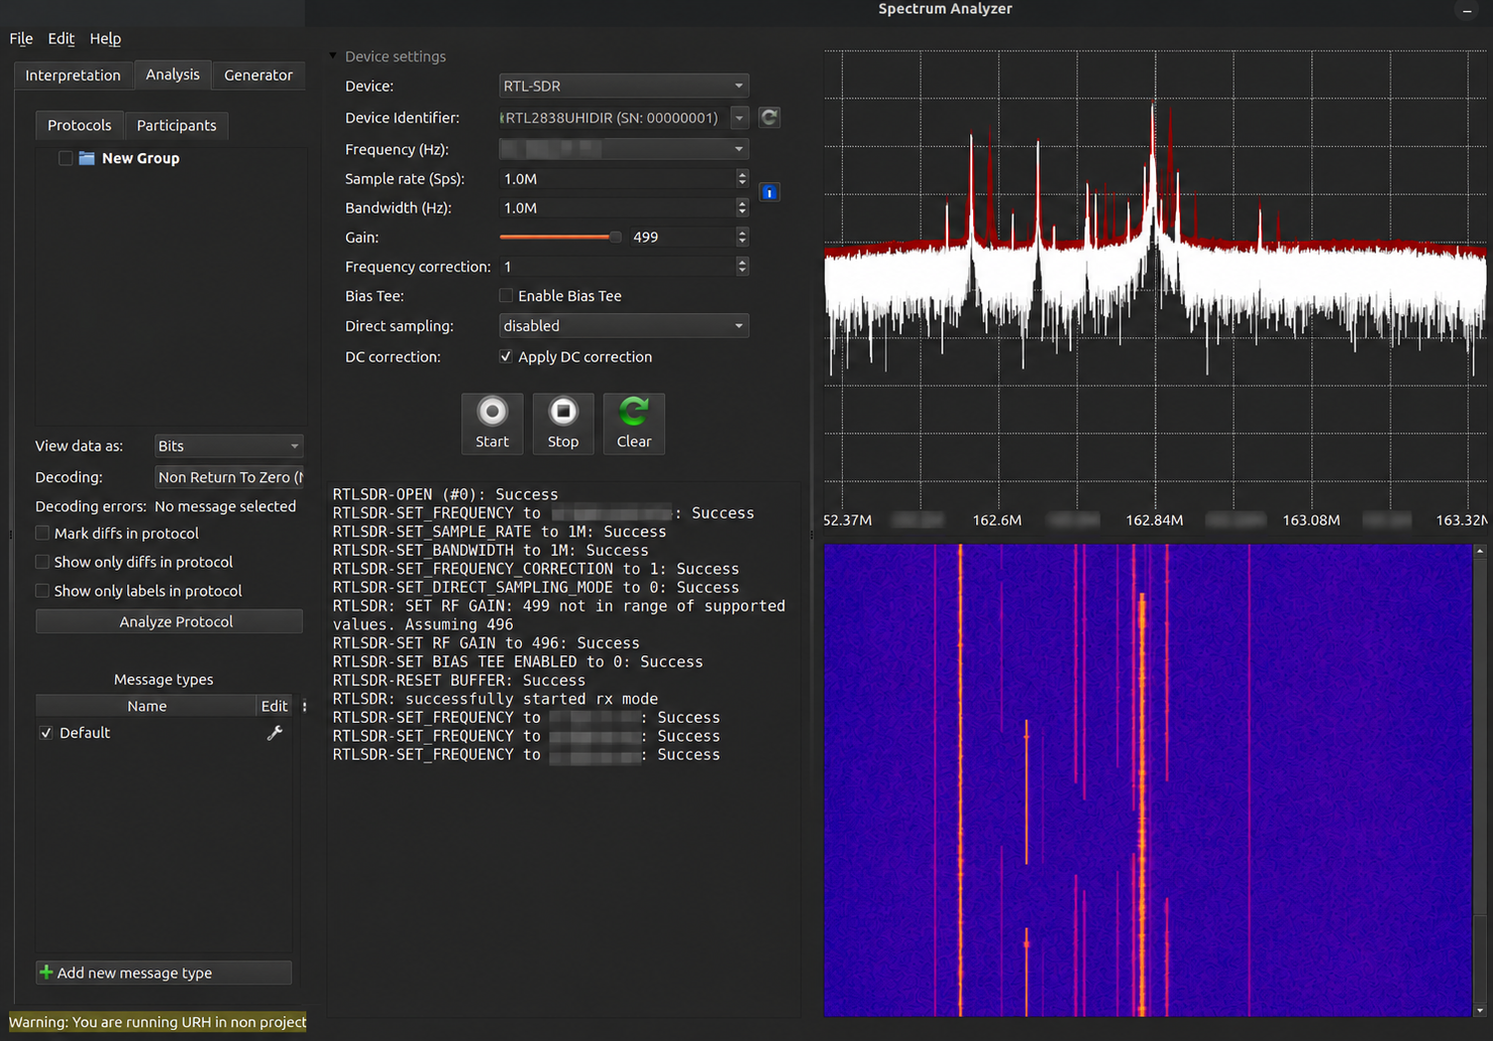
Figure 1. URH spectrum and waterfall view. Frequency values and selected log values are blurred; the visible peaks and waterfall illustrate signal activity, not a confirmed vulnerability.
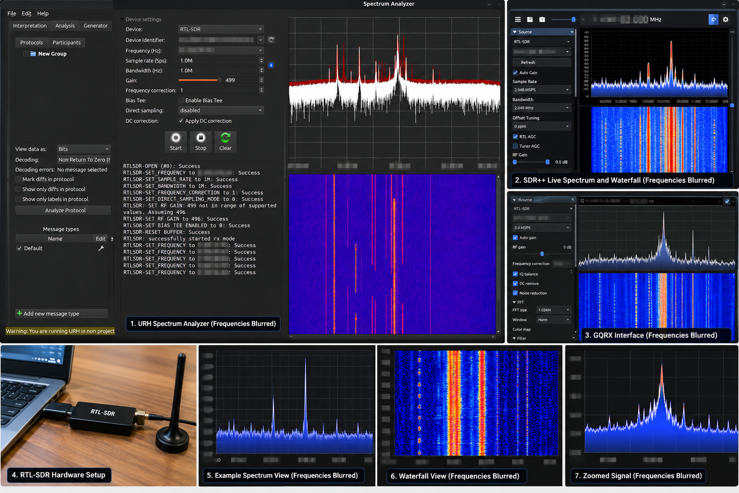
Figure 2. Illustrative overview of SDR interfaces, hardware and signal visualizations. Treat this as a conceptual reference collage; use authentic, verified application screenshots for tool-specific claims.

7.3 Common beginner mistakes
- Assuming every peak is a separate transmitter or a meaningful message.
- Changing several receiver settings at once and losing the ability to compare results.
- Confusing signal detection with protocol decoding or decryption.
- Assuming a failed decode proves the protocol is secure—or that a successful decode proves it is vulnerable.
- Ignoring antenna placement, overload, local interference and receiver limitations.
- Transmitting without verifying the legal and operational conditions.

8. Map the Complete Attack Surface
An RF-enabled product can expose several layers. A useful assessment map includes:

Radio interface
Frequency use, modulation, message framing and supported wireless protocols.

Device and firmware
Boot process, updates, debug interfaces, local storage and cryptographic key handling.

Protocol and trust
Pairing, device identity, authentication, authorization, message integrity, freshness and session behavior.

Gateway and network
Bridges between radio and IP networks, APIs, management ports, cloud connections and access control.

Operational process
Provisioning, lost-device handling, revocation, monitoring, incident response and safe fallback.
This layered model prevents a common mistake: testing only what can be seen over the air while ignoring the software that decides whether a message should be trusted.

9. Where RF Security Appears in the Real World

9.1 RFID and NFC
These technologies support identification and short-range interactions. Security questions include whether the system relies on a static identifier, how credentials are protected, whether the reader authenticates the credential, and whether access decisions are enforced securely.

9.2 Bluetooth and IoT
Bluetooth and low-power wireless devices often connect sensors, peripherals and controllers. Testing may examine pairing, bonding, device permissions, exposed services, firmware updates and whether sensitive operations require authentication.

9.3 Mobile phones and cellular networks
A smartphone combines application software, operating-system services, a cellular modem or baseband, Wi-Fi, Bluetooth, NFC and other radios. A mobile security assessment may cross several layers: application permissions, device configuration, radio protocol behavior, SIM-related security and network-side controls. These are related but distinct disciplines.

9.4 Aviation and navigation
Aviation and navigation systems can use radio broadcasts and satellite signals. Researchers must understand that publicly receivable signals are not necessarily authenticated or intended as control channels. Testing that transmits or interferes with operational systems can create serious safety risks; use passive data, simulations and controlled labs.

9.5 Satellite communications
Satellite communications depend on more than the signal in space. The ground segment, gateways, control systems, terminals, software, credentials and operational procedures are all part of the security picture. The final installments of this series will examine these layers and the differences between observing a signal and gaining access to a system.

10. Building a Safe Beginner Lab
A useful first lab does not require expensive equipment or active transmission. Start with a receive-only SDR, a suitable antenna, a computer and software such as SDR++ or GNU Radio. Learn with known public signals where reception is lawful, or with sample recordings and synthetic signals.
- Install the receiver software and confirm that the device is detected.
- Start with a known, lawful signal or a provided sample recording.
- Change one setting at a time and note the effect.
- Observe the spectrum and waterfall; record the settings and conditions.
- Use offline files to practice processing without transmitting.
- Write down what the evidence demonstrates and what remains unknown.
Before any active transmission, confirm local spectrum rules, equipment requirements, permitted power and frequency, and whether a shielded or otherwise compliant test environment is required. Never experiment by transmitting into live aviation, emergency, cellular or navigation services. Do not test systems you do not own or have explicit authorization to assess.

11. Ethics, Law and Responsible Disclosure
Authorization is part of the technical scope, not an administrative afterthought. A written scope should specify devices, locations, time windows, allowed techniques, transmission permissions, third-party dependencies, data handling and stop conditions.
Passive reception, decoding, recording and redistribution can also be subject to legal, privacy or service-specific restrictions. Check applicable local law and the terms governing the signals and equipment involved. If testing could affect safety-critical services, stop and redesign the experiment around simulation or an isolated lab.
When a weakness is found, preserve only the evidence necessary to demonstrate it, avoid collecting unrelated data, notify the responsible owner through an appropriate channel, and follow coordinated disclosure practices.

12. A Quick RF Security Checklist
- Is the wireless scope documented and authorized?
- Are devices and peers authenticated appropriately?
- Is sensitive data encrypted where needed?
- Are messages protected against unauthorized modification?
- Are replay and freshness protections implemented correctly?
- Are cryptographic keys stored, provisioned, rotated and revoked securely?
- Are firmware updates authenticated and protected against rollback where appropriate?
- Does the gateway validate radio-originated input before forwarding or acting on it?
- Can the system detect failures or suspicious behavior and recover safely?
- Are operational and safety requirements considered in testing?

Conclusion: Seeing the Signal Is Only the Beginning
RF technology connects devices across homes, offices, factories, vehicles, aircraft and space systems. Its signals may be invisible, but the systems that generate and consume them have identifiable components, trust relationships and security assumptions.
For a penetration tester, the job is not simply to find a frequency or capture a waveform. It is to understand the complete system, ask testable questions, gather evidence safely, distinguish observations from conclusions and explain how to reduce risk.
SDR provides an accessible entry point. RF physics explains what the receiver observes. Protocol analysis helps explain how messages are represented. Security testing determines whether the system trusts the right devices and protects the right operations.
The air may be invisible, but its attack surface is not.

Further Reading and Tools
- GNU Radio — https://www.gnuradio.org/
- RTL-SDR — https://www.rtl-sdr.com/
- Universal Radio Hacker — https://github.com/jopohl/urh
- SDR++ — https://github.com/AlexandreRouma/SDRPlusPlus
- HackRF — https://greatscottgadgets.com/hackrf/
- NIST Cybersecurity Publications — https://csrc.nist.gov/publications
- ITU — https://www.itu.int/
- Your national communications regulator — consult current spectrum and equipment rules before transmitting.

Coming Next: Part 2
RF Fundamentals for Security Researchers: Frequency, wavelength, modulation, bandwidth, antennas, sampling and signal propagation—explained with practical examples and a beginner-friendly SDR lab.

